Упражнение 10
- Създайте БД – Bikes в Access.
- Създайте 3 Таблици:
  - Models
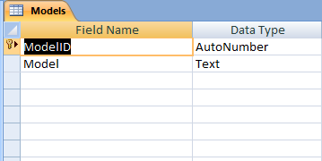
Ограничение за Model: 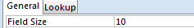
  - Versions
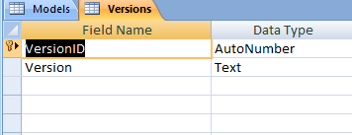
Ограничение за Version:
  - Bikes
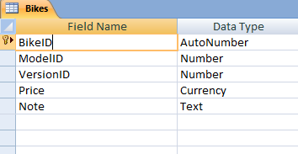
Ограничение за Note: 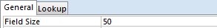

- Създайте Приложение Bikes в C#.
  - Добавете следните контроли: 1 GroupBox, 4 Labels, 4 TextBoxes, 1 Button1.
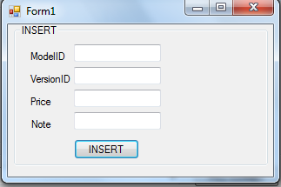
  - Свързване с БД:
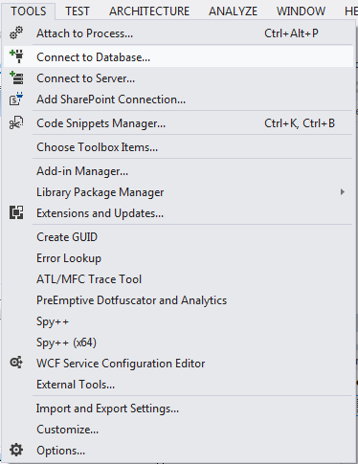
  - Изберете БД.
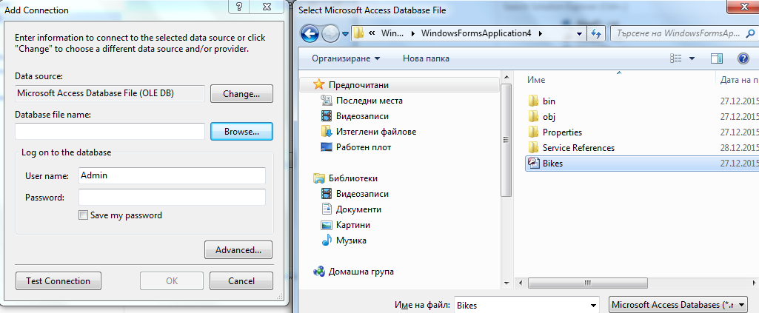
  - ОК.
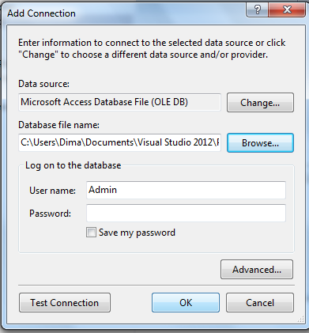
  - Ако всичко сте направили вярно то в Server Explorer, се появява БД Bikes.accdb.
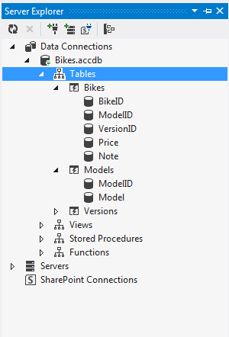
  - Добавете:
Код – Form1
using System;
using System.Collections.Generic;
using System.ComponentModel;
using System.Data;
using System.Drawing;
using System.Linq;
using System.Text;
using System.Threading.Tasks;
using System.Windows.Forms;

namespace WindowsFormsApplication4
{
public partial class Form1 : Form
{
Broker b = new Broker();

public Form1()
{
InitializeComponent();
}

private void Form1_Load(object sender, EventArgs e)
{
label1.Text = "ModelID";
label2.Text = "VersionID";
label3.Text = "Price";
label4.Text = "Note";
}

private void button1_Click(object sender, EventArgs e)
{
Person p = new Person();
p.ModelID1 = textBox1.Text;
p.VersionID1 = textBox2.Text;
p.Price1 = textBox3.Text;
p.Note1 = textBox4.Text;
b.Insert(p);
}
}
}
  - Добавете Class Broker

using System;
using System.Collections.Generic;
using System.Linq;
using System.Text;
using System.Threading.Tasks;
using System.Data.OleDb;
using System.Data;
using System.Windows.Forms;

namespace WindowsFormsApplication4
{
class Broker
{
OleDbConnection connection;
OleDbCommand command;
private void ConnectTo()
{
connection = new OleDbConnection("Provider=Microsoft.ACE.OLEDB.12.0;Data Source=C:\\Users\\Dima\\Documents\\Bikes.accdb");
command = connection.CreateCommand();
}
public Broker()
{
ConnectTo();
}

public void Insert(Person p)
{
try
{
//command.CommandText = "INSERT INTO Bikes(ModelID, VersionID, Price, [Note]) VALUES (1, 2, 1, 'asa')";
command.CommandText = "INSERT INTO Bikes(ModelID, VersionID, Price, [Note]) VALUES (" + p.ModelID1 + "," + p.VersionID1 + "," + p.Price1 + "," + "'" + p.Note1 + "'"+ ")";
command.CommandType = CommandType.Text;
// command.Connection = connection;
connection.Open();
command.ExecuteNonQuery();
}
catch (Exception)
{
//throw;
MessageBox.Show("Некоректни данни! Моля въведете отново!");
}
finally
{
if (connection != null)
{
connection.Close();
}
}
}
}
}

  - Добавете Class Person

using System;
using System.Collections.Generic;
using System.Linq;
using System.Text;

namespace WindowsFormsApplication4
{
class Person
{
public string BikeID1 { get; set; }
public string ModelID1 { get; set; }
public string VersionID1 { get; set; }
public string Price1 { get; set; }
public string Note1 { get; set; }
}
}
  - Добавете class Domain

using System;
using System.Collections.Generic;
using System.Linq;
using System.Text;
using System.Threading.Tasks;

namespace WindowsFormsApplication4
{
class Domain
{
int BikeID;

public int BikeID1
{
get { return BikeID; }
set { BikeID = value; }
}
int ModelID;

public int ModelID1
{
get { return ModelID; }
set { ModelID = value; }
}
int VersionID;

public int VersionID1
{
get { return VersionID; }
set { VersionID = value; }
}
double Price;

public double Price1
{
get { return Price; }
set { Price = value; }
}
string Note;

public string Note1
{
get { return Note; }
set { Note = value; }
}
}
}

